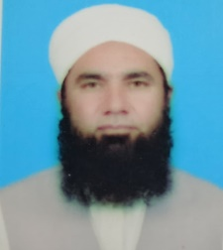 CV

Dr. Mufti Muhammad Iltimas Khan

Chairman, Department of Seerat Studies University of Peshawar)

Post Doc: International Islamic University, Islamabad

PhD in Islamic Studies: University of Peshawar

M.Phil in Arabic: University of Peshawar

M.A in Islamic Studies & Arabic: Wifaqul Madaris Al-Arabia, Multan

Specialization in Fiqh Islami Jamia Islamia Al-Faridia, E7, Islamabad

Published Article 43 in HEC Recognized Journals

Cell No: +92333-9733713

E-mail: [muftiiltimas@uop.edu.pk](mailto:muftiiltimas@uop.edu.pk)

Phone No: 091-9221176

E-mail: [seerat_studies@uop.edu.pk](mailto:seerat_studies@uop.edu.pk)